Salesforce CRM Project Documentation

Project Title: To Supply Leftover Food to Poor

Application: FoodConnect

Prepared By: [Dilleswari Maddi]

Date: [03-08-2025]

College: Aditya Institute Of Technology And Management

Roll Number: 22A51A04G2

# Table of Contents

1. Project Overview  
2. Objectives  
3. Phase 1: Requirement Analysis & Planning  
4. Phase 2: Salesforce Development - Backend & Configurations  
5. Phase 3: Salesforce Development - Relationships & Fields  
6. Phase 4: Automation  
7. Phase 5: Reports, Dashboards, and Sharing  
8. Phase 6: Deployment, Testing & Maintenance  
9. Conclusion  
10. Appendix (Screenshot Placeholders)

Ongoing maintenance ensures the FoodConnect application remains reliable, secure, and up-to-date. The following activities are performed on a regular basis:  
- Weekly review of debug logs to identify and fix automation errors.  
- Monthly audit of public groups to ensure membership accuracy.  
- Quarterly review of sharing rules to match current operational needs.  
- Regular archiving of old records to maintain system performance.  
- Monitoring flow error logs and applying fixes immediately.  
- Collecting and reviewing user feedback for improvements.  
- Updating dashboards and reports to reflect evolving KPIs.

# 1. Project Overview

The project 'To Supply Leftover Food to Poor' uses Salesforce (FoodConnect app) to coordinate venues offering leftover food, drop-off points, volunteers, tasks, and execution details. The objective is to minimize food waste by systematically collecting surplus food and distributing it to those in need.

# 

# 2. Objectives

Key objectives include: reducing food waste, automating coordination between venues and volunteers, ensuring transparency via tracking, and providing actionable reporting while maintaining secure access for NGOs and stakeholders.

# 3. Phase 1: Requirement Analysis & Planning

## 3.1 Understanding Business Requirements

The system must capture venue information, drop-off locations, assign tasks to volunteers, and log execution details of food deliveries. It should enable NGO users to see relevant records based on proximity and roles, and provide dashboards to monitor operations.

## 3.2 Project Scope

Scope includes:  
- Creation of custom objects: Venue, Drop-Off Point, Task, Volunteer, Execution Details.  
- Configuration of relationships: Master-Detail and Lookup for linking related records.  
- Implementation of automation: Flows and Apex triggers.  
- Security setup: Profiles, Public Groups, Sharing Rules based on distance criteria.  
- Reporting and dashboard creation for operational visibility.

## 3.3 Data & Security Model Design

Data model comprises:

* - Venue, Drop-Off Point, Task, Volunteer, Execution Details objects with appropriate relationships.
* - Lookup and Master-Detail relationships to enforce data integrity and hierarchy.

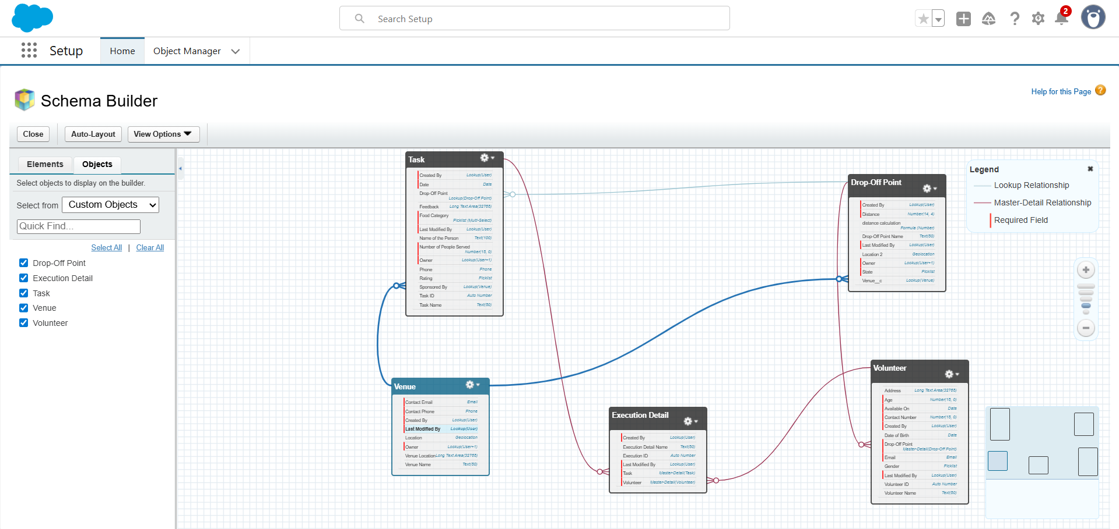

Security model comprises:

* - Custom profile 'NGOs Profile' cloned from Standard Platform User.
* - Public groups for NGOs (Iksha, NSS, Street Cause) and role-based visibility.
* - Sharing rules on Drop-Off Point based on Distance calculation to grant access.

# 4. Phase 2: Salesforce Development - Backend & Configurations

## 4.1 Custom Object Creation

### Object: Venue

* Plural Label: Venues
* Record Name: Venue Name
* Data Type: Text
* Options: Allow Reports, Track Field History, Allow Activities, Allow Search

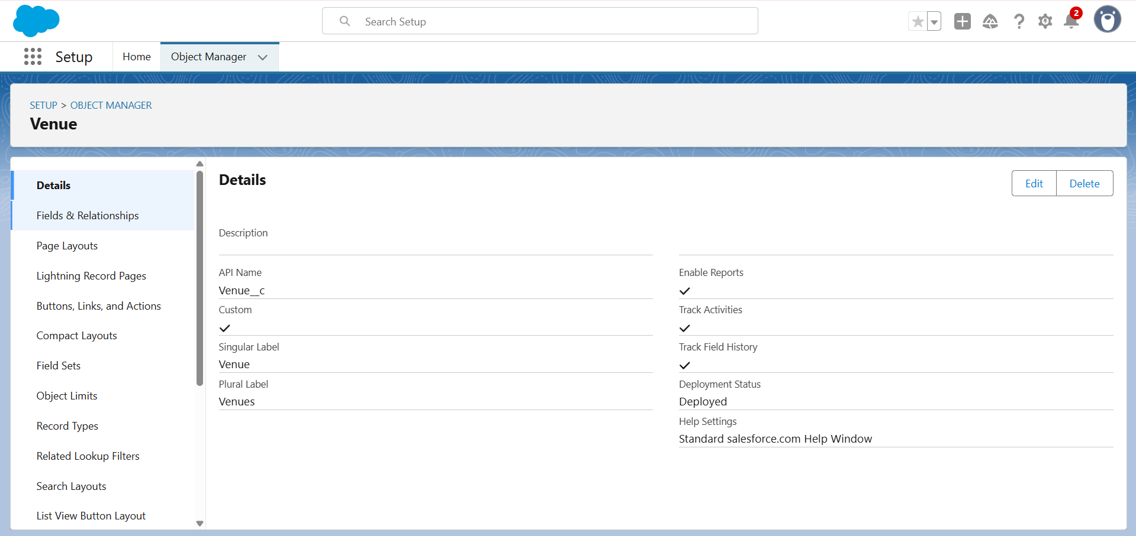

### Object: Drop-Off Point

* Plural Label: Drop-Off Points
* Record Name: Drop-Off Point Name
* Data Type: Text
* Options: Allow Reports, Track Field History, Allow Activities, Allow Search

### Object: Task

* Plural Label: Tasks
* Record Name: Task Name
* Data Type: Text
* Options: Allow Reports, Track Field History, Allow Activities, Allow Search

### Object: Volunteer

* Plural Label: Volunteers
* Record Name: Volunteer Name
* Data Type: Text
* Options: Allow Reports, Track Field History, Allow Activities, Allow Search

### Object: Execution Detail

* Plural Label: Execution Details
* Record Name: Execution Detail Name
* Data Type: Text
* Options: Allow Reports, Track Field History, Allow Activities, Allow Search

## 4.2 Tab and App Setup

Custom Tab creation for Venue and other objects and creation of Lightning App 'FoodConnect' with navigation items: Home, Venue, Drop-Off Point, Task, Volunteer, Execution Details, Reports. System Administrator profile added to the app.

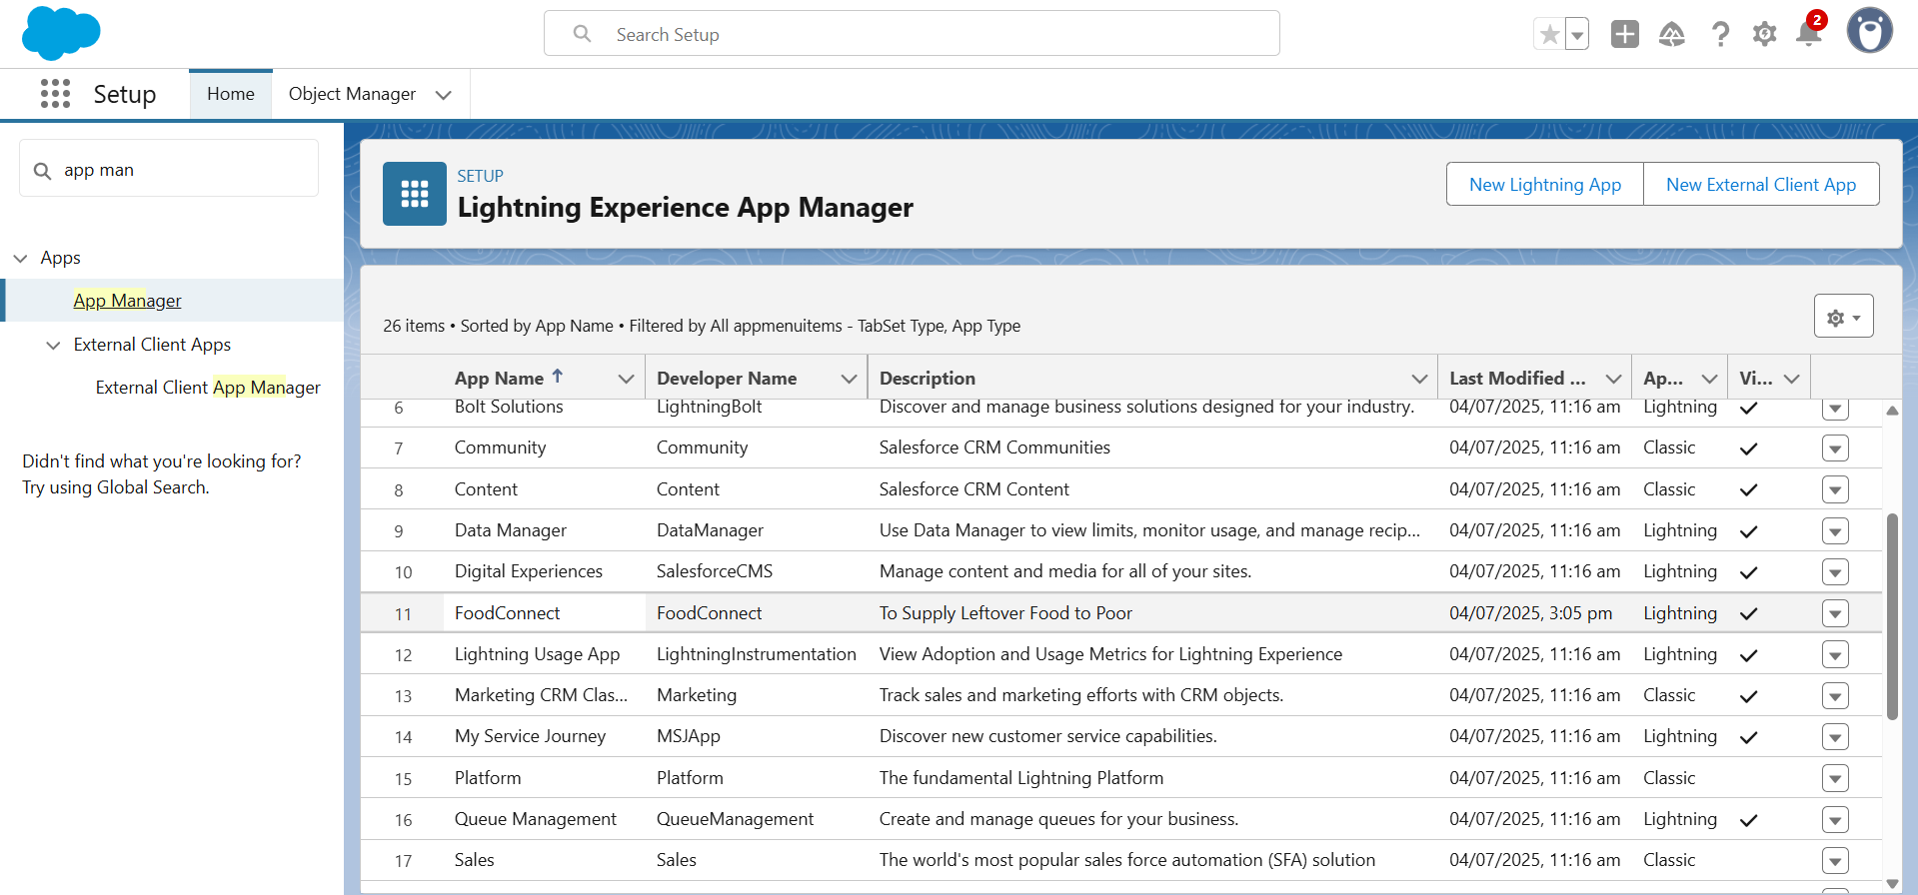

# 5. Phase 3: Salesforce Development - Relationships & Fields

## 5.1 Relationship Fields

* Volunteer object has Master-Detail relationship to Drop-Off Point.
* Execution Details has Master-Detail relationships to Volunteer and Task.
* Drop-Off Point has Lookup relationship to Venue.
* Task has Lookup relationships to Venue (Sponsored By) and Drop-Off Point.

## 5.2 Venue Fields

* Fields added to Venue object:
* - Contact Email (Email, required)
* - Contact Phone (Phone, required)
* - Location (Geolocation, 4 decimal places)
* - Venue Location (Long Text Area)

## 5.3 Drop-Off Point Fields

* - Location 2 (Geolocation, Decimal Places 4)
* - Distance Calculation (Formula: DISTANCE(Location_2__c, Venue__r.Location__c, 'km'))
* - State (Picklist, required) with list of Indian states and UTs

## A screenshot of a computer AI-generated content may be incorrect. 5.4 Task Fields

* - Distance (Number, length 14, decimal 4, required)
* - Task ID (Auto Number: TASK-{0}, required)
* - Date (Date, required)
* - Food Category (Multi-Select Picklist: Veg, Non-Veg, Salad, Snack, required)
* - Number of People Served (Number, required)
* - Name of the Person (Text)
* - Phone (Phone)
* - Rating (Picklist: 1-5)
* - Feedback (Long Text Area)

## 5.5 Volunteer Fields

* - Volunteer ID (Auto Number, required)
* - Gender (Picklist: Female, Male)
* - Available On (Date, required)
* - Age (Number, required)
* - Email (Email, required)
* - Contact Number (Number, required)
* - Address (Text Area Long)
* - Date of Birth (Date)

## 5.6 Execution Details Fields

* - Execution ID (Auto Number, required) A screenshot of a computer

  AI-generated content may be incorrect.

# 6. Phase 4: Automation

## 6.1 Flow: Venue Details Entry

A Screen Flow named 'Venue Form' captures Venue details including Venue Name, Contact Email, Contact Phone, Venue Location, Latitude, and Longitude. It uses a Create Record element to save the input into the Venue object.

## 6.2 Apex Trigger: DropOffTrigger

Trigger on Drop-Off Point (before insert) to assign Distance Calculation value to Distance field, enabling distance-based sharing rules.

Code snippet:

trigger DropOffTrigger on Drop_Off_point__c (before insert) {  
 for(Drop_Off_point__c Drop : Trigger.new){  
 Drop.Distance__c = Drop.distance_calculation__c;  
 }  
}

## 6.3 Security Configuration

Custom Profile: NGOs Profile cloned from Standard Platform User to limit access appropriately. Public Groups created: Iksha, NSS, Street Cause. Users created (e.g., Iksha Foundation) assigned to NGOs Profile.

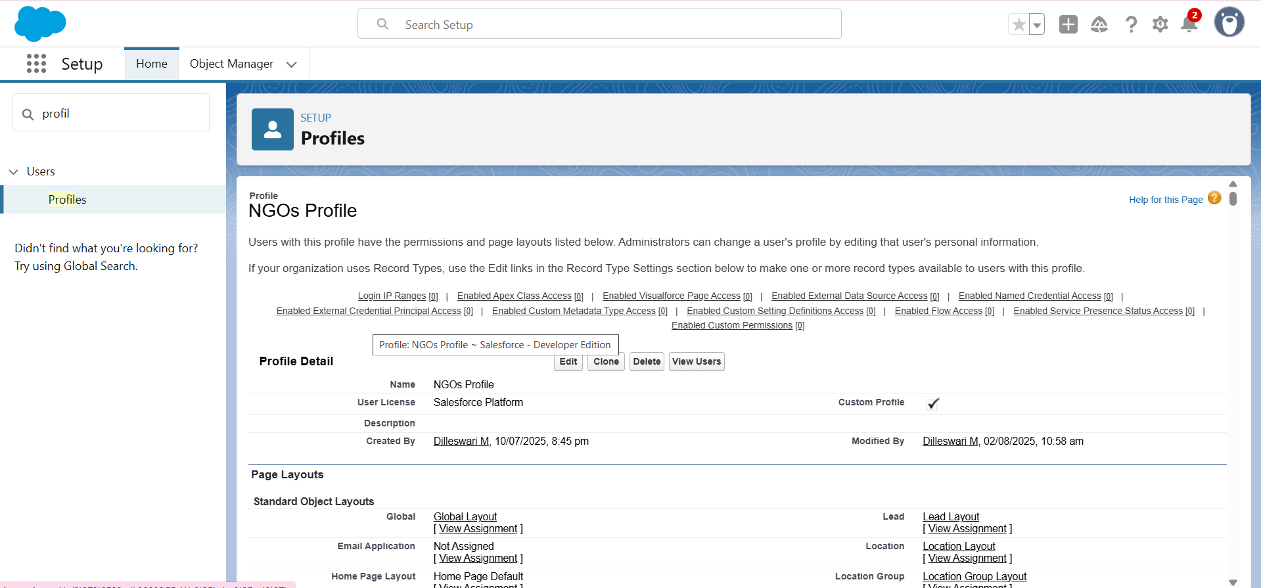

# 7. Phase 5: Reports, Dashboards, and Sharing

## 7.1 Report Types

Custom report type 'Venue with DropOff with Volunteer' was created with primary object Venues, related to Drop-Off Points and Volunteers.

## 7.2 Reports

Report: Venue and Drop-Off Point

- Group Rows: Volunteer Name

- Columns: Venue Name, Drop-Off Point Name, Distance

## 7.3 Volunteer Task Report

Custom report 'Volunteer Task' uses Volunteers with Execution Details and Tasks report type.

- Group Rows: Volunteer ID

- Columns: Volunteer Name, Task Name, Execution Detail Name, Owner Name, Date, Rating

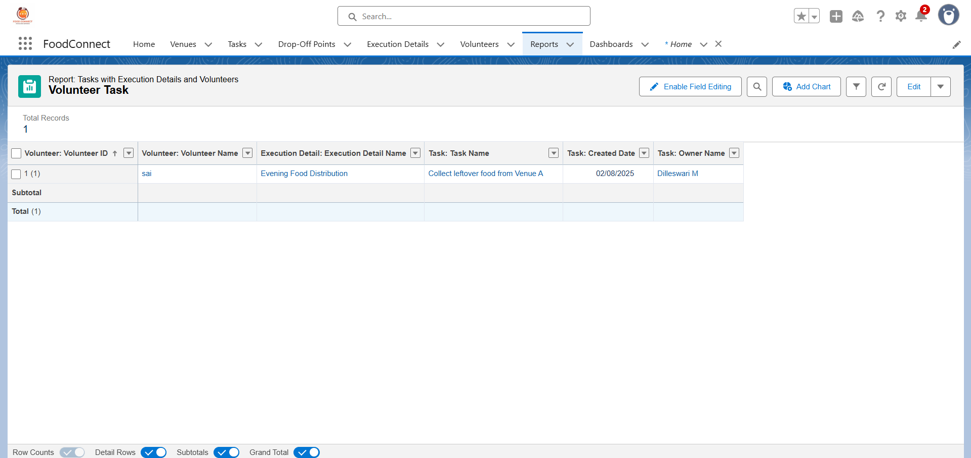

## 7.4 Dashboards

Dashboard: Organization Details - includes Venue and Drop-Off Point report displayed as Lightning Table.

Dashboard: Task Execution Details - includes Volunteer Task report displayed as Line Chart.

# 8. Phase 6: Deployment, Testing & Maintenance

## 8.1 Deployment Strategy

Deployment used change sets to move configurations from development to production. Components included objects, fields, flows, triggers, profiles, sharing rules, and dashboards.

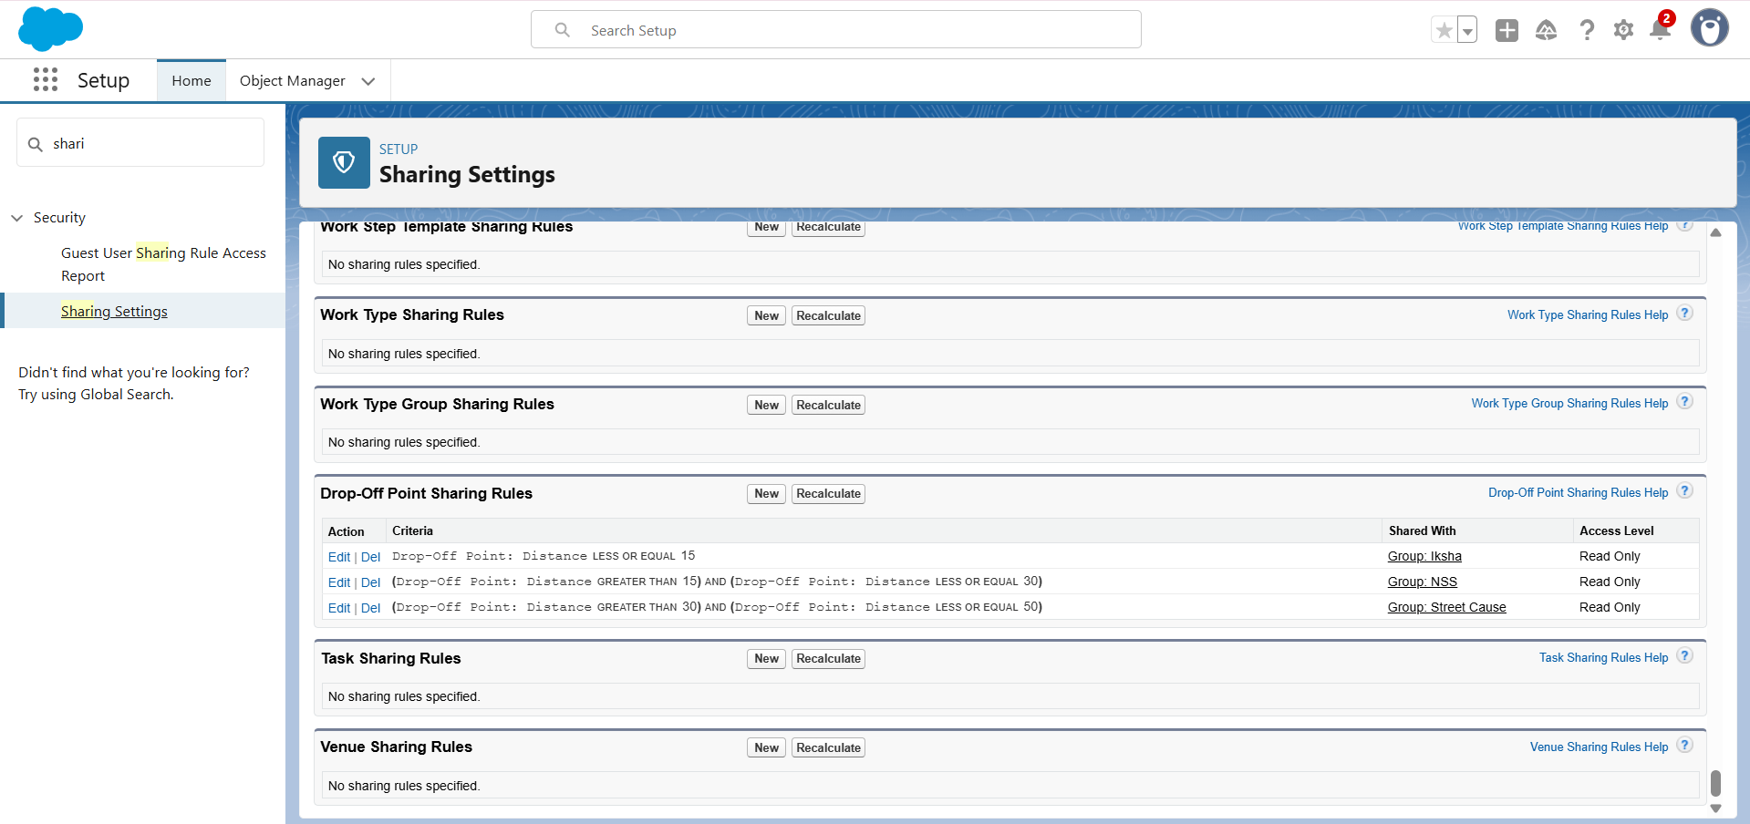

NOTE: In Developer Edition, Change Sets are unavailable, so deployment is simulated within the same org.

**Activating a flow** will represent “deployment” illustration.

## 8.2 Testing Approach

The testing process followed a structured approach to ensure that all components functioned as expected. Testing was performed in phases, covering unit testing, integration testing, and user acceptance testing.  
  
Below is the detailed testing table:

Test cases included:  
- Venue creation via flow  
- Drop-Off Point sharing based on distance  
- Trigger validation for distance assignment  
- Report generation and dashboard rendering  
- User access verification through cloned NGO profiles

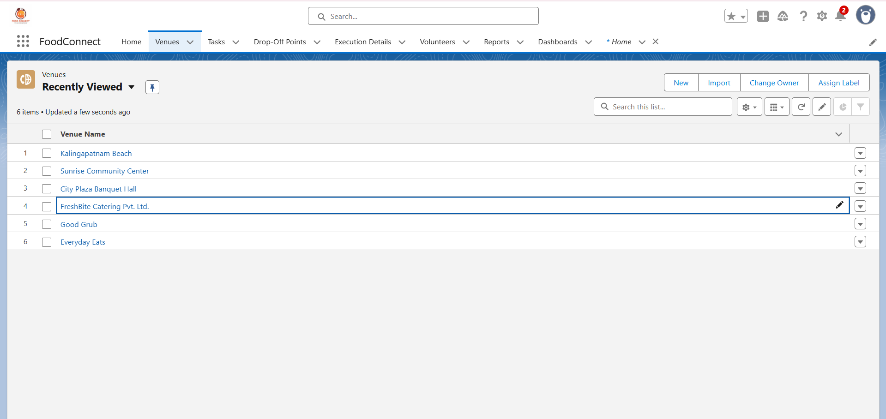

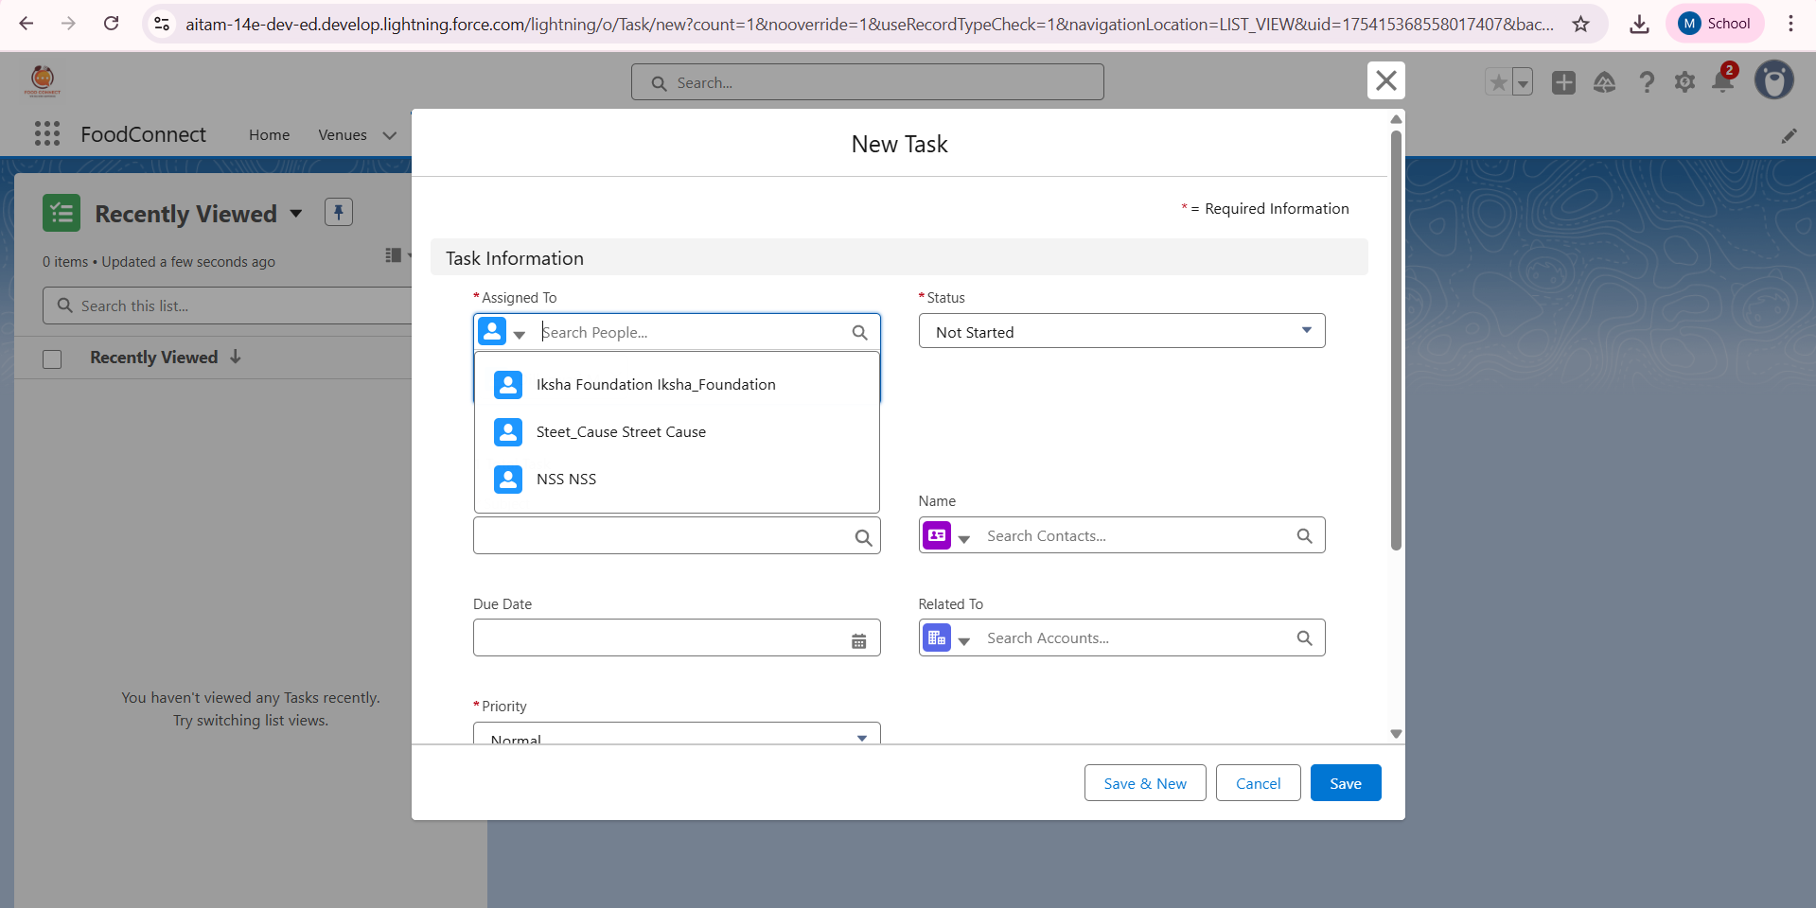

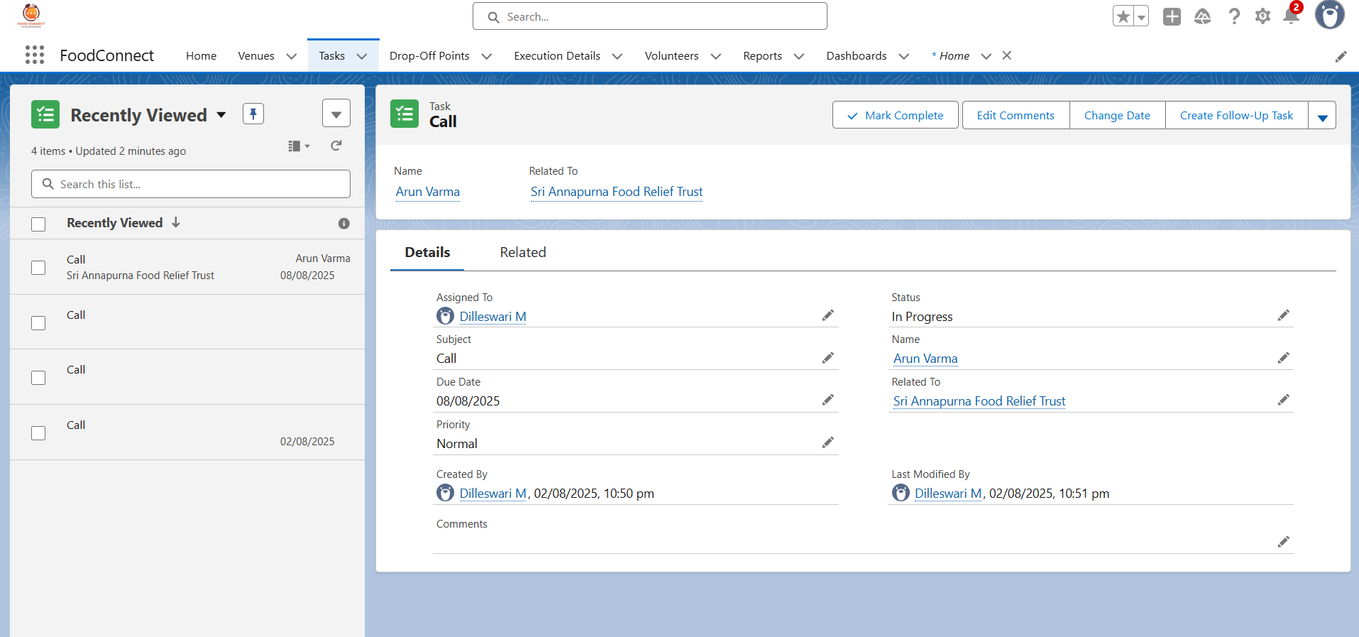

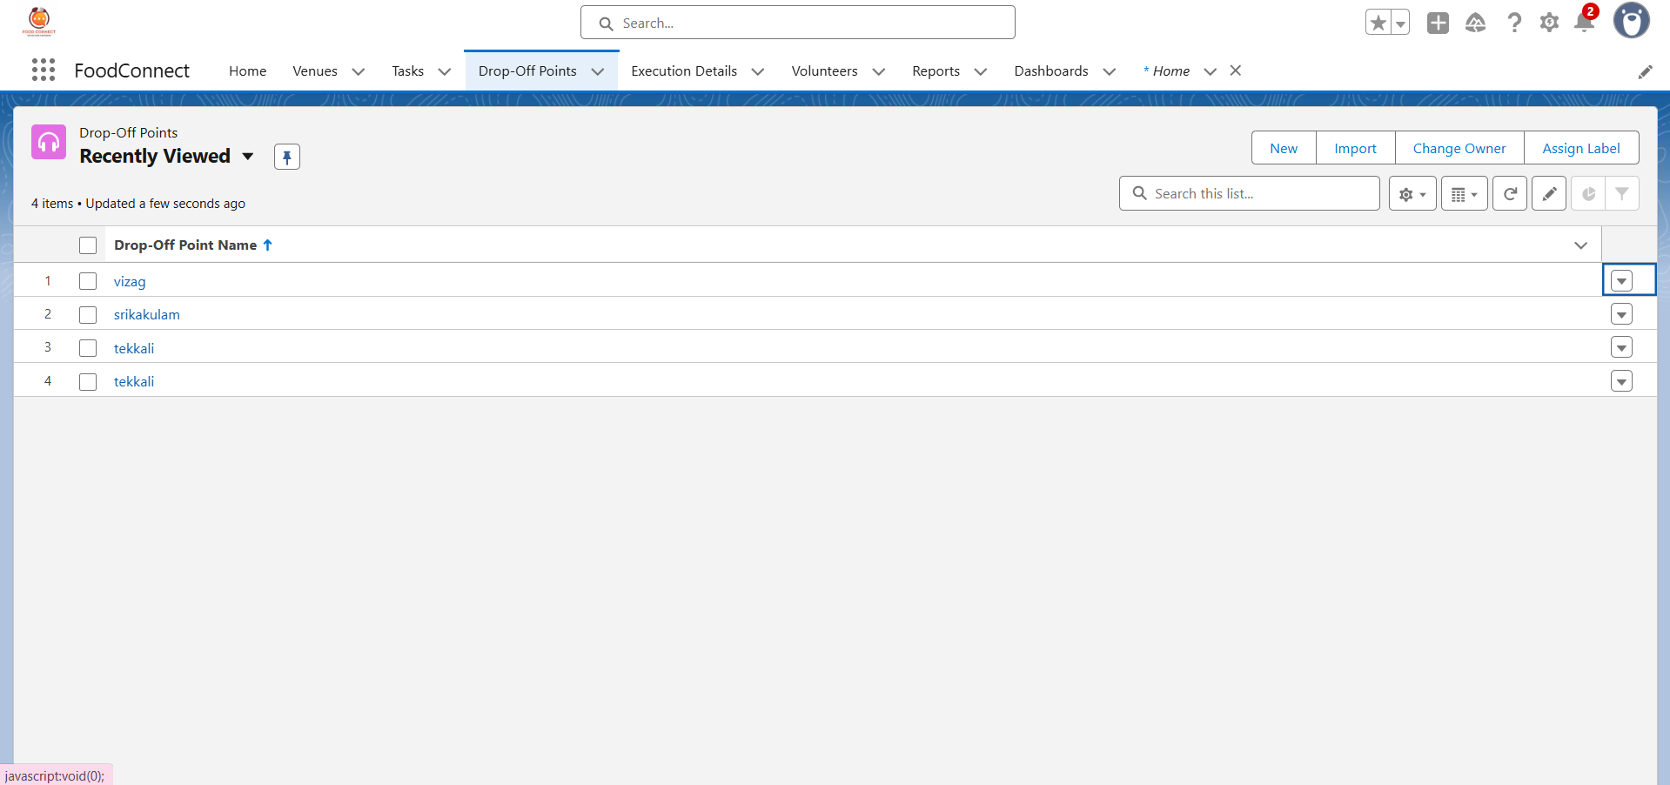

## 8.3 Maintenance

Ongoing maintenance involves reviewing debug logs, updating public groups, and auditing sharing rules to ensure correct visibility and operational integrity.

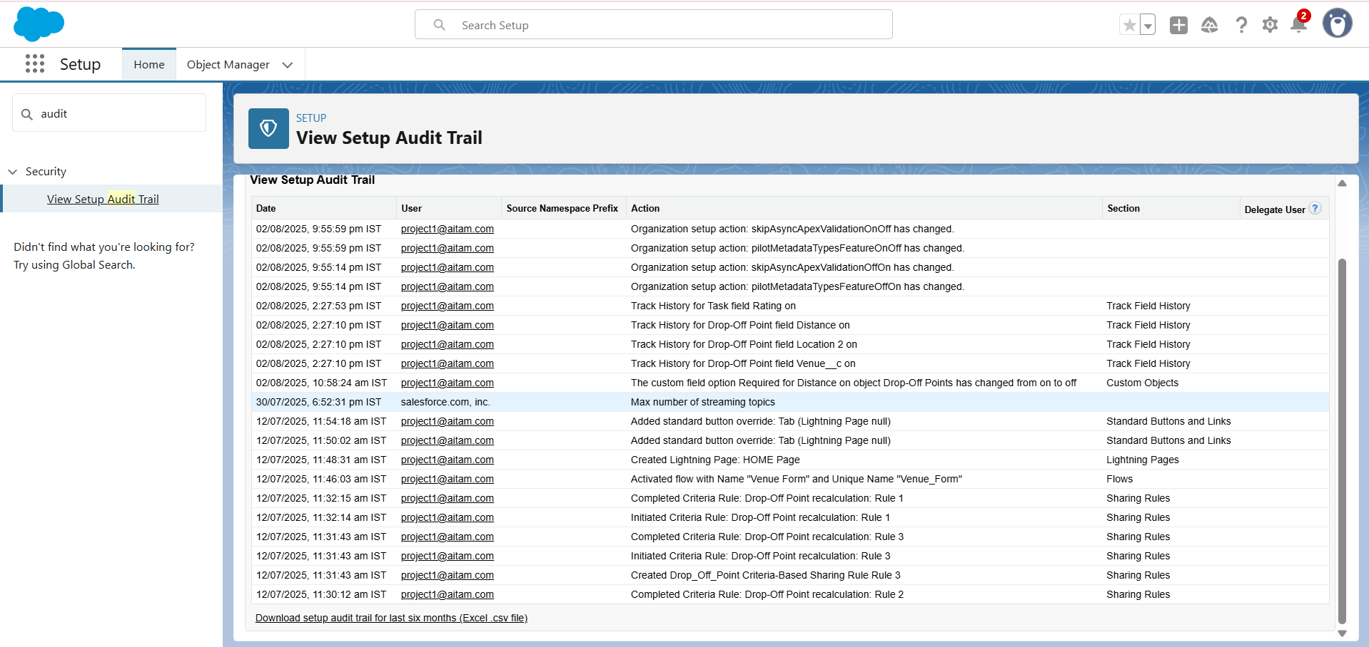

# 9. Conclusion

The FoodConnect Salesforce CRM implementation successfully created an automated, secure, and transparent system for supplying leftover food to the poor. By combining custom objects, flows, triggers, and sharing rules, the project ensures efficient coordination among venues, volunteers, and execution teams, while enabling NGOs to access relevant data and generate insights through reports and dashboards.

# 10. Appendix: Screenshot Placeholders

* - FoodConnect Home Page
* - Object Manager Schema
* - Venue Object Definition
* - Drop-Off Point Object Definition
* - Task Object Definition
* - Volunteer Object Definition
* - Execution Details Object Definition
* - Flow: Venue Form
* - Trigger: DropOffTrigger
* - Report Types
* - Venue and Drop-Off Point Report
* - Volunteer Task Report
* - Dashboards
* - Profiles and Public Groups
* - Sharing Rules
* - Test Case Execution

|  |  |  |  |  |
| --- | --- | --- | --- | --- |
| Test Case ID | Description | Expected Result | Actual Result | Status |
| TC001 | Create Venue via Flow | Venue record created with correct details | As expected | Pass |
| TC002 | Trigger assigns Distance to Drop-Off Point | Distance field populated automatically | As expected | Pass |
| TC003 | Volunteer Task Report generation | Report shows correct volunteer-task mapping | As expected | Pass |
| TC004 | Dashboard displays latest data | Dashboard updated with correct metrics | As expected | Pass |
| TC005 | Sharing rules work as intended | Only intended groups can view records | As expected | Pass |

TC001:

Creating Venue via Flow

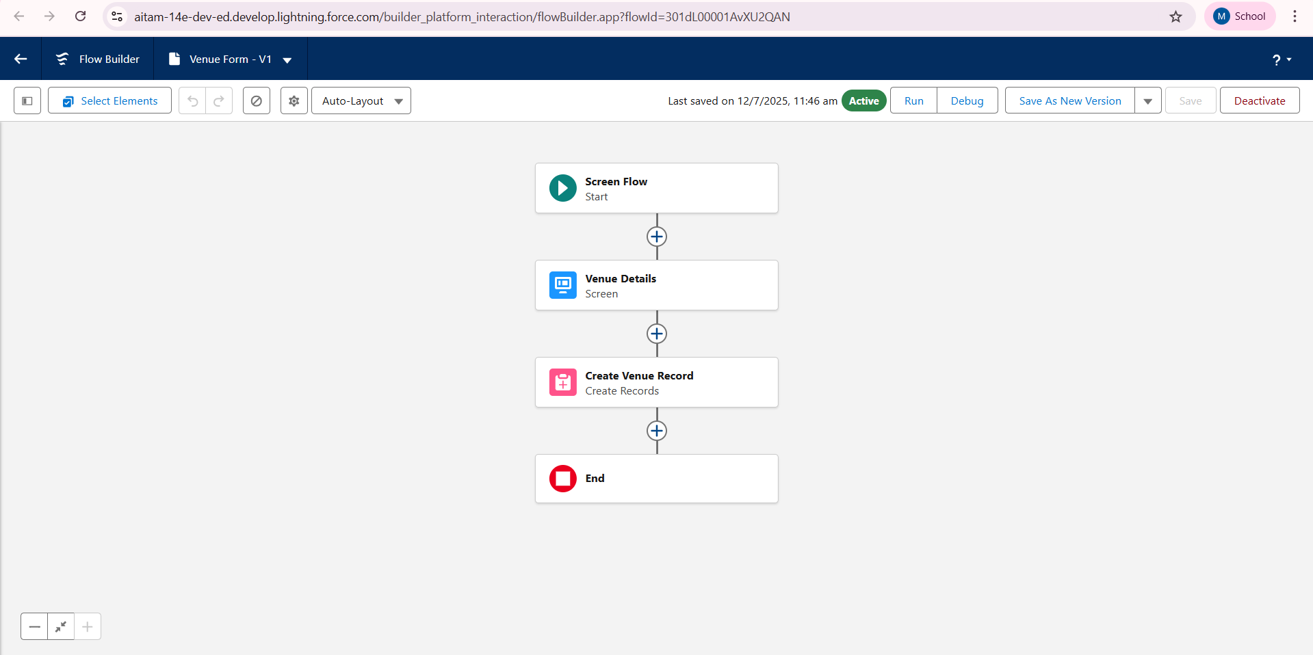

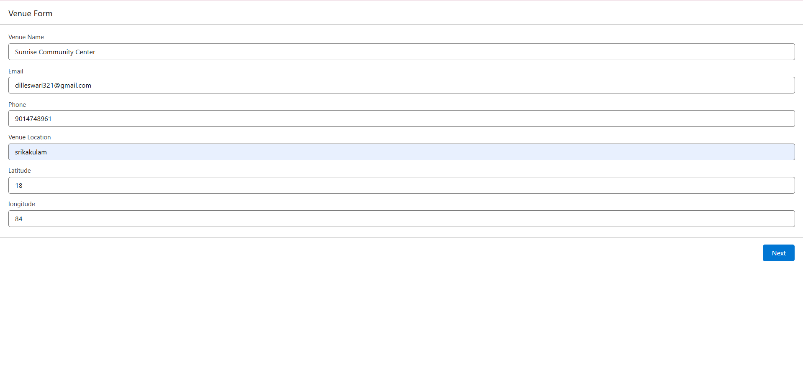

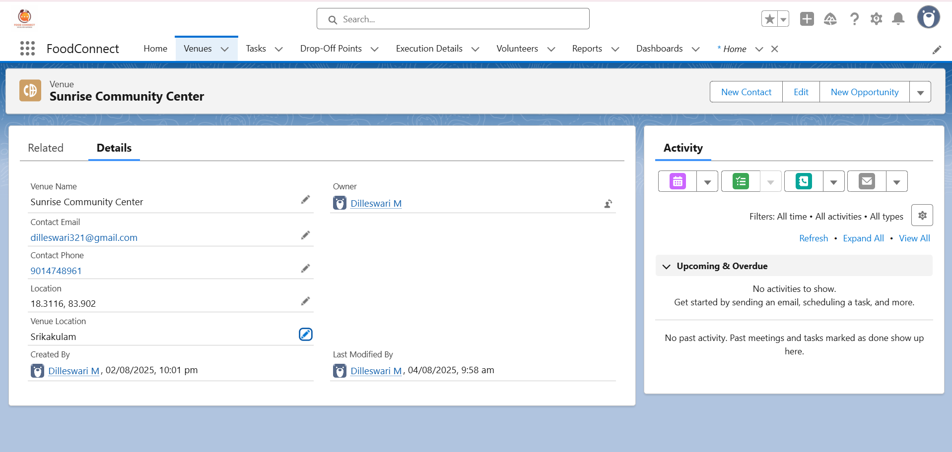

TC002:

Trigger assigns Distance to Drop-Off Point

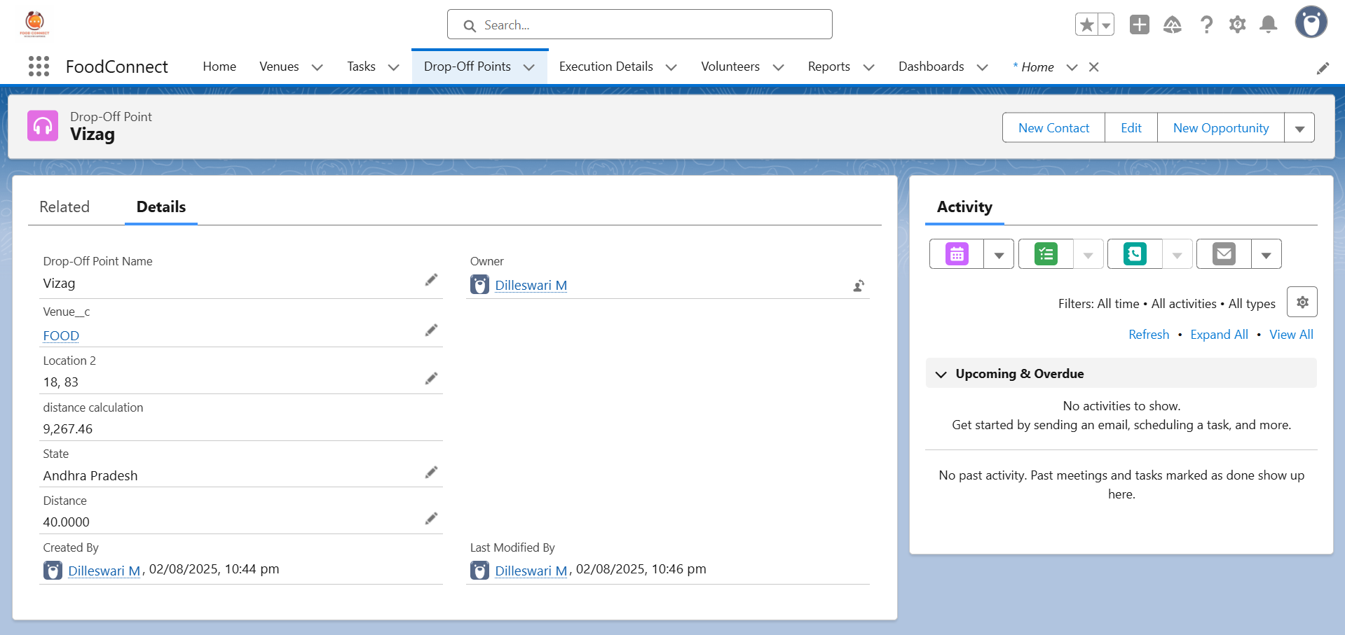

TC003:

Volunteer Task Report generation

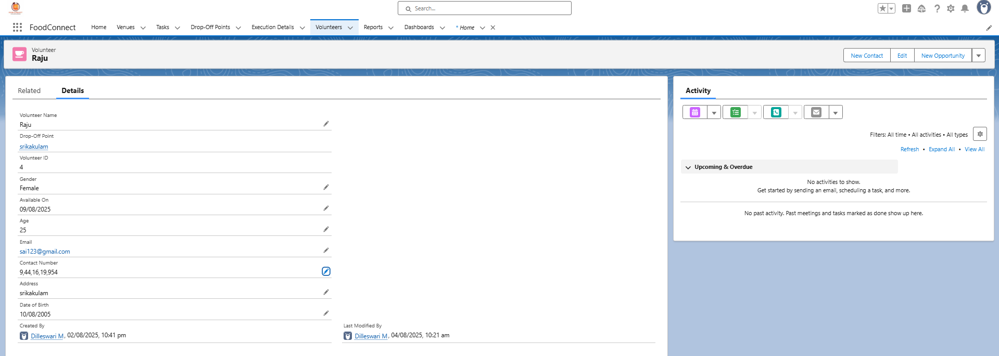

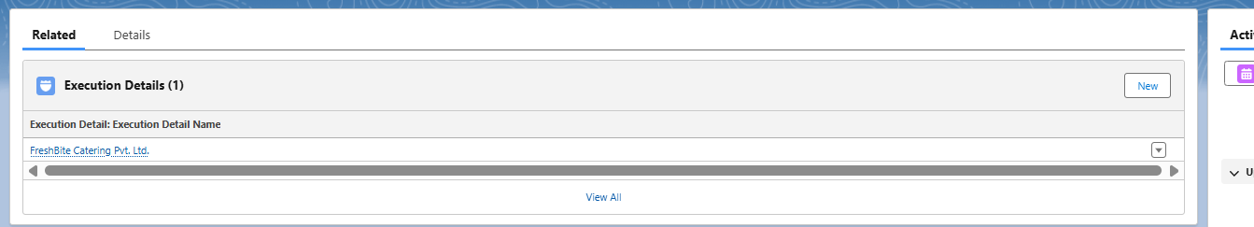

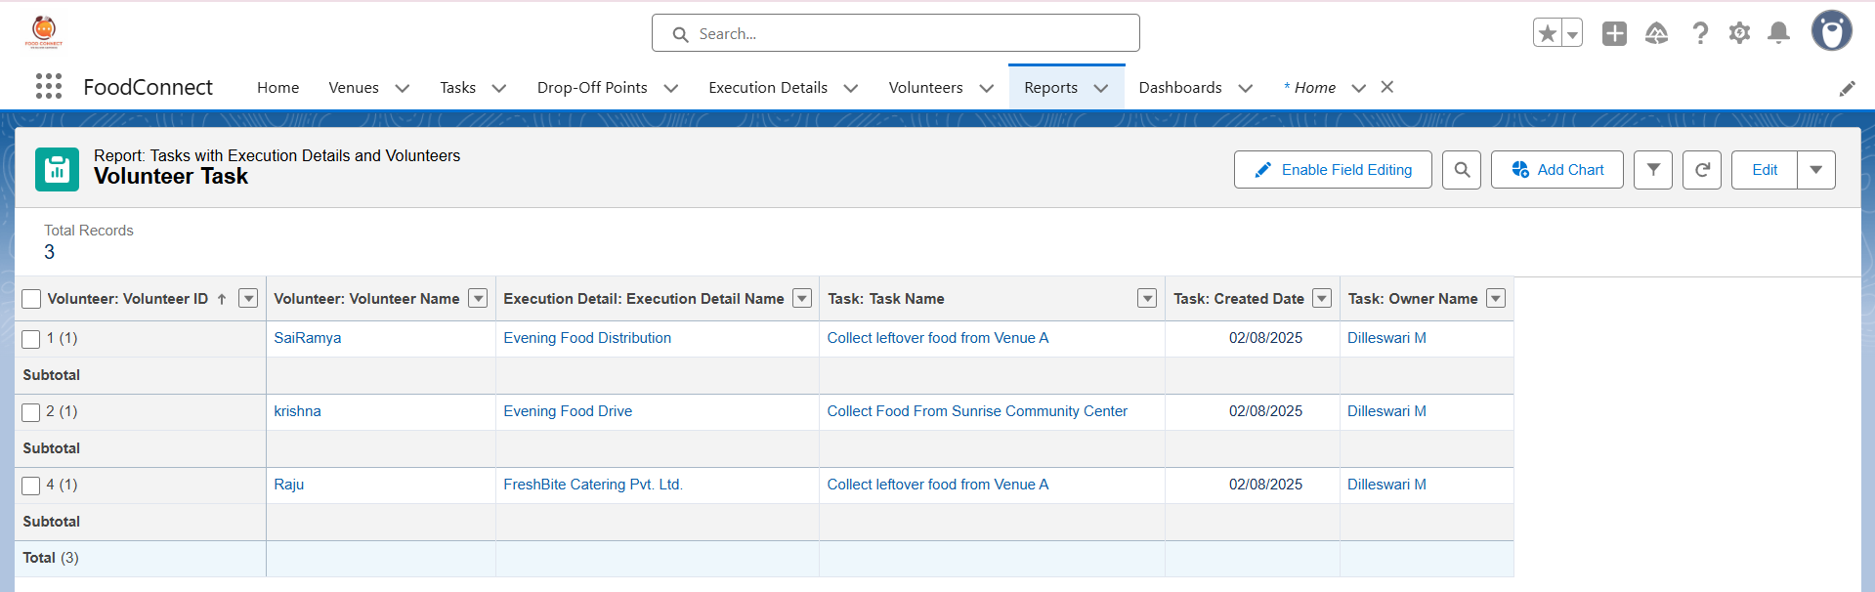

TC004:

Dashboard displays latest data

Dashboard before:

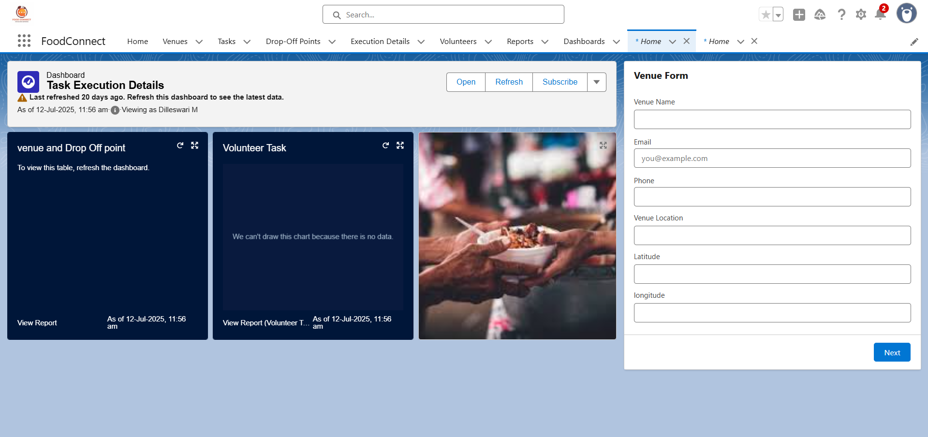

Dashboard after:

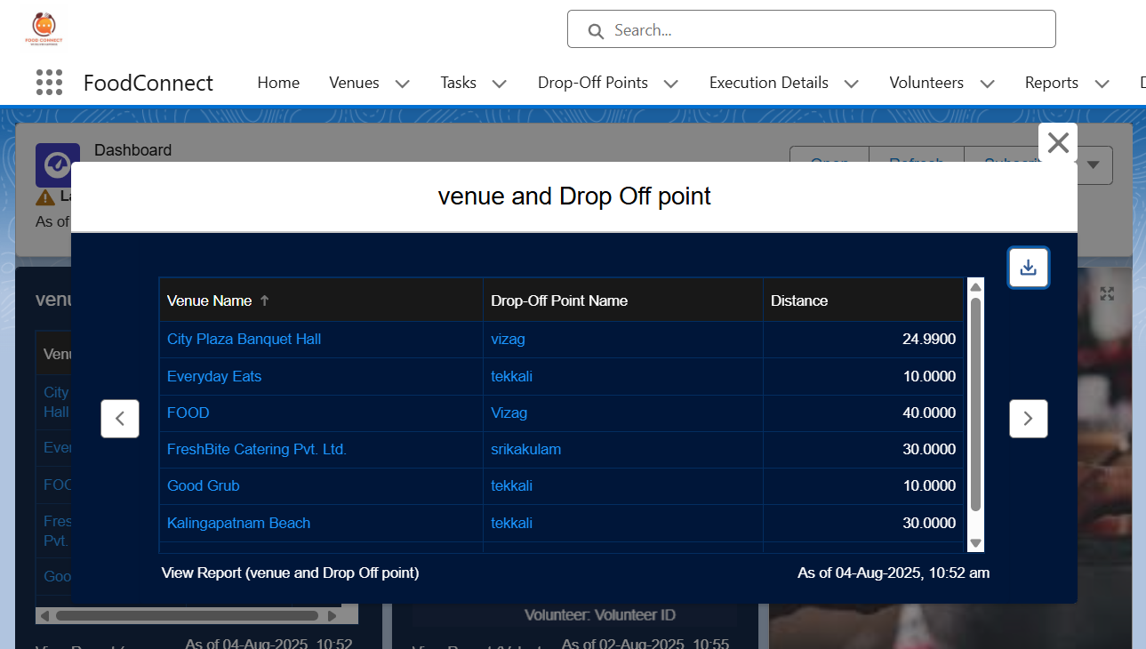

TC005:

Sharing rules work as intended.

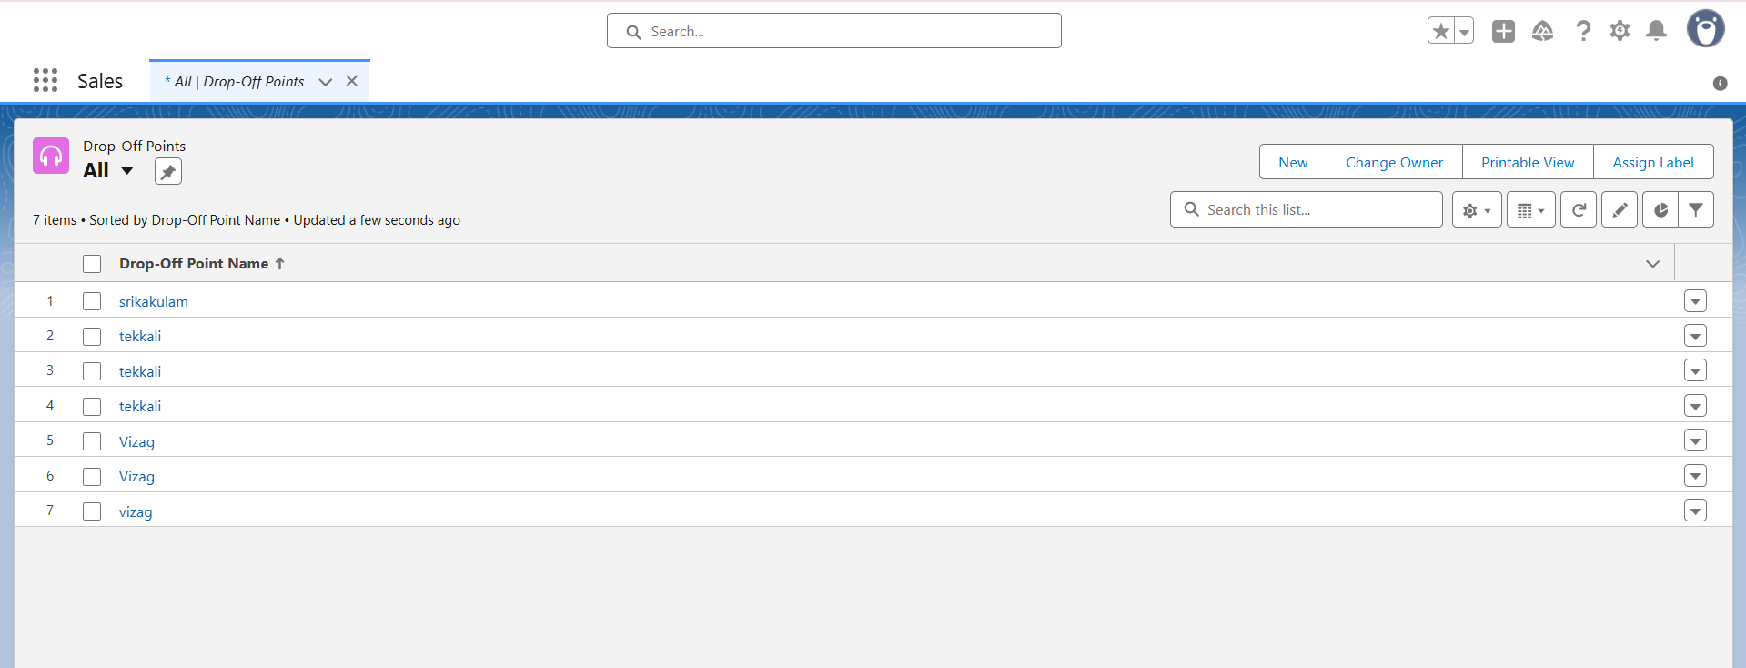

# Appendix A: Schema Diagram



To capture this:  
1. Go to Setup → Schema Builder.  
2. Select the custom objects used in this project.  
3. Arrange them so that relationships are clearly visible.  
4. Take a screenshot including all fields and relationship lines.

# Appendix B: Sample Data for Testing

Sample Venue Records:

|  |  |  |
| --- | --- | --- |
| Venue Name | Latitude | Longitude |
| City Plaza Banquet Hall | 18.2960 | 83.8966 |
| Heritage Grand Hotel | 18.3116 | 83.9020 |
| Metro Mall Food Court | 18.3500 | 84.1333 |

Sample Volunteer Records:

|  |  |  |
| --- | --- | --- |
| Volunteer Name | Gender | Contact Number |
| Ravi Kumar | Male | 9876543210 |
| Priya Sharma | Female | 9441619954 |

Sample Task Records:

|  |  |
| --- | --- |
| Task Name | Date |
| Collect food from GreenLeaf Banquet | 2025-07-30 |
| Deliver meals to Railway Station Shelter | 2025-07-31 |

Sample Execution Detail Records:

|  |  |
| --- | --- |
| Execution Detail Name | Date |
| Evening Food Drive – Srikakulam Central | 2025-07-29 |
| Lunch Distribution – Arasavalli Temple Area | 2025-07-30 |